ERGONOMIC CONSIDERATIONS IN DESIGN
  - In a machine design, the machine is considered as an entity in itself. However, in reality, the man (operator), machine and working environment form the system and this system needs to be considered as a single unit.
  - Ergonomics is defined as the scientific study of the man-machine-working environment relationship and the application of anatomical, physiological and psychological principles to solve the problems arising from this relationship.
  - The word ‘ergonomics’ is formed from two Greek words : ‘ergon’ (work) and ‘nomos’ (natural laws).
  - The final objective of the ergonomics is to make the machine fit for user rather than to make the user adapt himself or herself to the machine. It aims at decreasing the physical and mental stresses to the user.
- Areas Covered Under Ergonomics :
The different area covered under the ergonomics are :
1. Communication Between Man (User) and Machine;
2. Working Environment;
3. Human Anatomy and Posture While Using the Machine; and
4. Energy Expenditure in Hand and Foot Operations.
1.7 COMMUNICATION BETWEEN MAN (USER) AND MACHINE
  - Fig. 1.10 shows the man-machine closed loop system. The machine has a display unit and a control unit.
  - A man (user) receives the information from the machine display through the sense organs.
  - He (or she) then takes the corrective action on the machine controls using the hands or feet.
  - This man-machine closed loop system in influenced by the working environmental factors such as : lighting, noise, temperature, humidity, air circulation, etc.
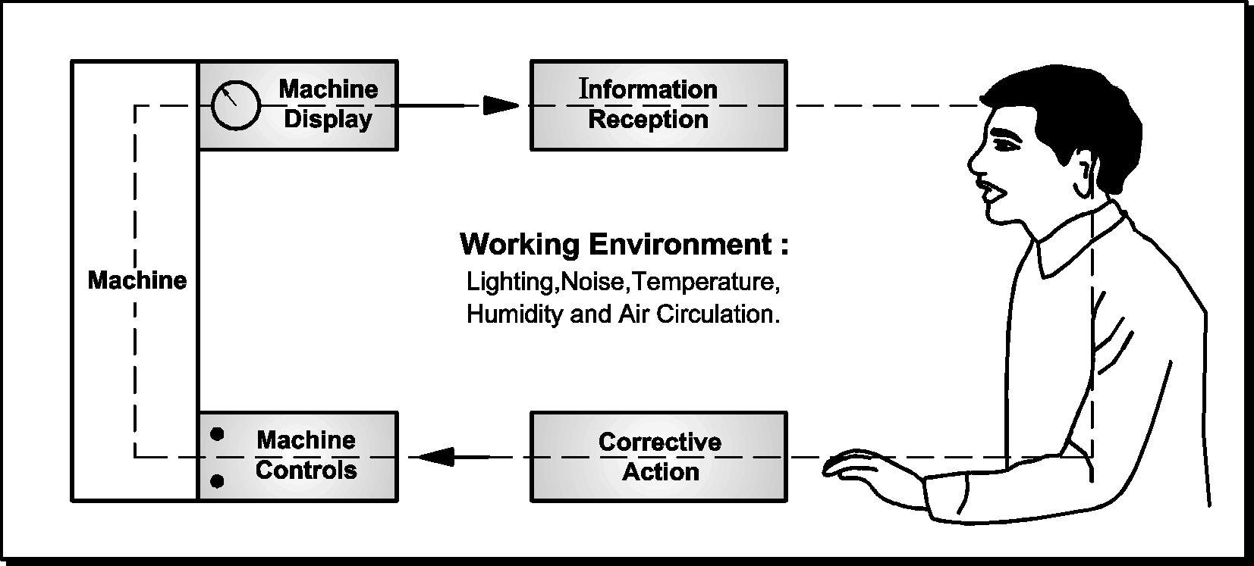

Fig. 1.10 : Man-Machine Closed Loop System

  - The communication system between the man (user) and the machine consists of the displays and the controls.
  - The man-machine system has two important units :
1. Displays
2. Controls.

  - The considerations in the design of the displays and the controls are discussed below :
1.7.1 Design of Displays :
Displays are the devices through which the man (user) receives the information from the machine.
A good display device is one which allows the proper combination of speed, accuracy and sensitivity of display.
The display devices can be broadly classified into two categories :
1. Qualitative Displays
2. Quantitative Displays.
1. Qualitative Displays :
  - The displays which indicate only the condition or state without giving the values are known as qualitative displays.
  - The examples of the qualitative displays are : traffic signals and on-off indicators.
  - The qualitative displays are of following types :
(i) Circular dial [Fig. 1.11(a)] ;
(ii) Straight legend [Fig. 1.11(b)] ; or
(iii) Coloured lights [Fig. 1.12].
(a) Circular Dial (b) Straight Legend
Fig. 1.11 : Qualitative Display by Pointer

Fig. 1.12 : Qualitative Display by Coloured Lights
  - The qualitative display by a light can be made more effective by the use of flashing light, sometimes accompanied by the auditory warning.
2. Quantitative Displays :
  - The displays which give the quantitative measurements or numerical information are known as quantitative displays.
  - The examples of the quantitative displays are : voltmeters, ammeters, speedometers, energy meters, watches, etc.
  - The quantitative displays are of the following types :
(i) Moving pointer - fixed scale type displays [Fig. 1.13];
(ii) Fixed pointer - moving scale type displays [Fig. 1.14]; and
(iii) Digital displays [Fig. 1.15].
(i) Moving pointer - fixed scale type displays :
The moving pointer - fixed scale type displays [Fig. 1.13] are easy to read than the fixed pointer - moving scale type displays [Fig. 1.14], and hence they are more common in use.

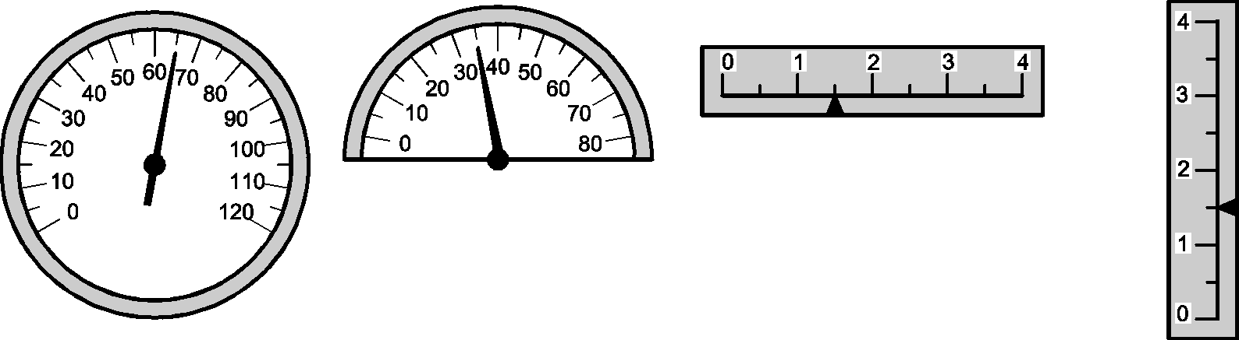
(a) Circular Scale (b) Semi-Circular Scale (c) Horizontal Scale (d) Vertical Scale
Fig. 1.13 : Moving Pointer-Fixed Scale Type Displays
(ii) Fixed pointer - moving scale type displays :
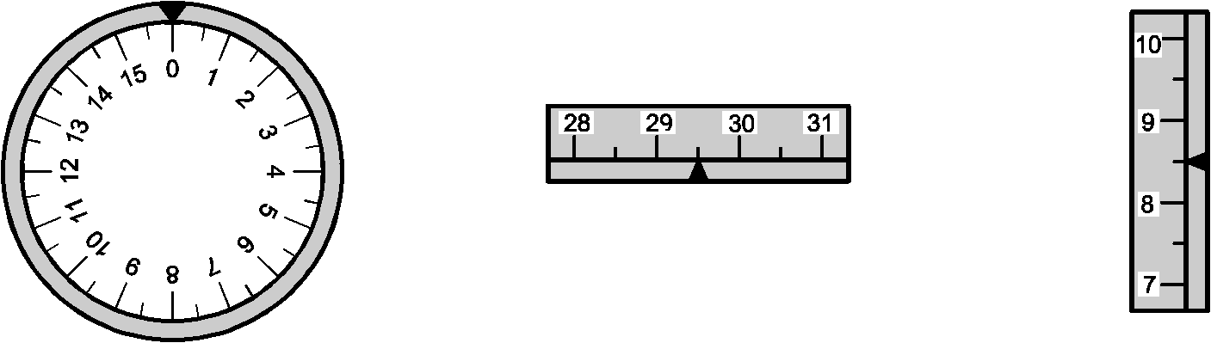
Whenever the values are to be read over the wide range, the fixed pointer-open window type displays [Fig. 1.14(b) and (c)] are more efficient than the moving pointer-fixed scale type displays.

(a) Circular Scale (b) Open Window with (c) Open Window with
Horizontal Scale Vertical Scale
Fig. 1.14 : Fixed Pointer-Moving Scale Type Displays
(iii) Digital displays :
The digital display [Fig. 1.15] is most accurate of all the displays.
Fig. 1.15 : Digital Display
1.7.2 Ergonomic Considerations in Design of Displays :
The basic objective in the design of the displays is to minimize the fatigue to the user. The ergonomic considerations in the design of the displays are as follows :
1. The scale should be clear and legible.
2. The size of the numbers or letters on the scale should be taken such that,
Height of the number or letter ≥
3. The scale should be divided in a linear progression such as 0 – 10 – 20 – 30… and
not as 0 – 5 – 25 – 45…..
4. The number of subdivisions between the numbered divisions should be as minimum
as possible.
5. The vertical numbers should be used for the moving pointer type displays with circular scales as shown in Figs. 1.13(a) and 1.13(b), while the radially oriented numbers should be used for the fixed pointer type displays with circular scales as shown in Fig. 1.14(a).
6. The vertical numbers should be used for the vertical and horizontal scales as, shown in
Figs. 1.13(c), 1.13(d), 1.14(b) and 1.14(c).
7. The numbering should be in clockwise direction on a circular scale, from left to right on a horizontal scale and from bottom to top on a vertical scale.
8. The pointer should have a knife-edge with a mirror in a dial to minimize the parallax error while taking the readings.
9. When a display and its associated control are to be placed near each other, the control device should be placed either below or to the right of the display, as shown in Fig. 1.16, so that the user's hand, operating the control is less likely to interfere while reading the display.
10. Whenever straight scales are to be used, the horizontal scales are preferred over the vertical scales because the vertical scales are more prone to the reading errors.
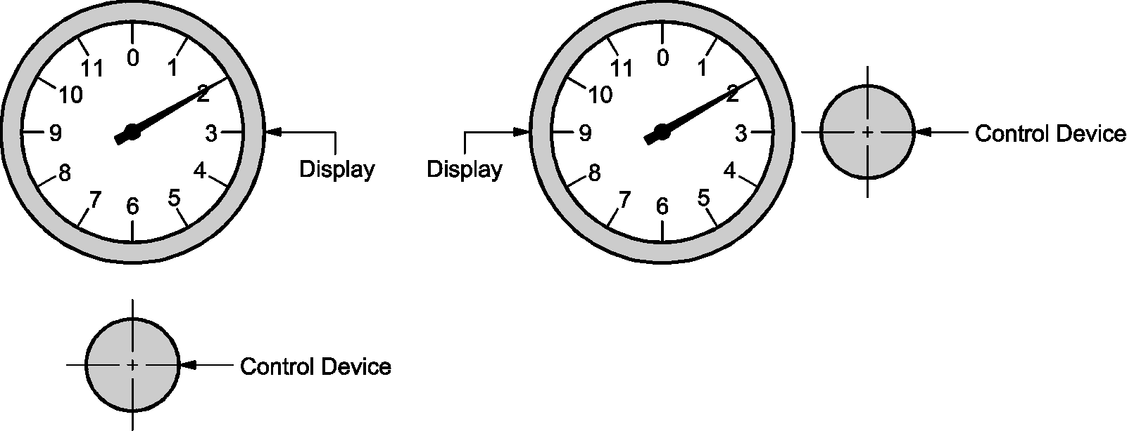

(a) Control Device Below Display (b) Control Device to the Right of Display
Fig. 1.16 : Arrangements for Easy Reading of Display
1.7.3 Design of Controls :
  - Controls are the devices through which the man (user) conveys his instructions to the machine.
  - Selection of control devices :
The type and size of the control device selected for a given application depends upon the following factors :
1. The required speed of operation;
2. The required accuracy of the control;
3 The required operating force;
4. The required range of the control;
5. The required direction of the control; and
6. The convenience of the user.
  - Types of controls :
The various types of controls used in machines are : Crank, hand-wheel, star-wheel hand-lever, foot pedal, knob, push-button, toggle switch, joystick, etc. (Refer Fig. 1.17).
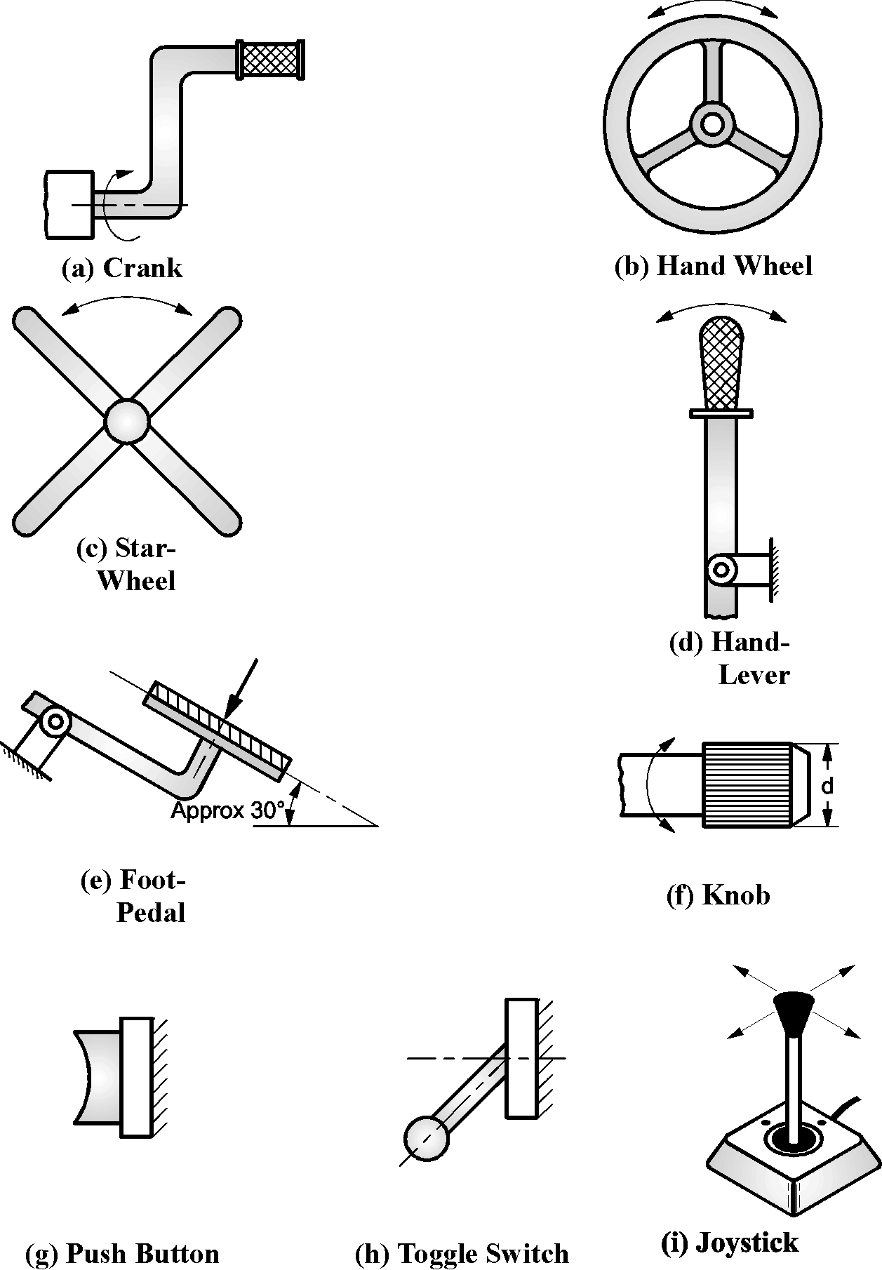

Fig. 1.17 : Types of controls
1.7.4 Ergonomic Considerations in Design of Controls :
The ergonomic considerations in the design of the controls are as follows :
1. The control devices should be logically positioned and easily accessible.
2. The control operation should involve minimum and smooth moments.
3. The control operation should consume minimum energy.
4. The portion of the control device which comes in contact with user's hand should be in conformity with the anatomy of human hands.
5. The proper colours should be used for control devices and backgrounds so as to give the required psychological effect.
6. The shape and size of the control device should be such that the user is encouraged to handle it in such a way as to exert the required force, but not excessive force, damaging the control or the machine.
1.8 WORKING ENVIRONMENT
The working environment affect significantly the man-machine relationship. It affects the efficiency and possibly the health of the operator. The major working environmental factors are :
1. Lighting,
2. Noise,
3. Temperature,
4. Humidity and Air Circulation.

1. Lighting :
  - The amount of light that is required to enable a task to be performed effectively depends upon the nature of the task, the cycle time, the reflective characteristics of the equipment involved and the vision of the operator.
  - Codes of practice are available that recommend the amount of light necessary for a certain task.
  - The intensity of light in the surrounding area should be less than that at the task area. This makes the task area the focus of attention.
  - Operators will become less tired if the lighting and colour schemes are arranged so that there is a gradual change in brightness and colour from the task area to the surroundings.
  - The task area should be located such that the operator can occasionally relax by looking away from the task area towards a distinct object or surface.
  - The distinct object or surface should not be so bright that the operator's eyes take time to adjust to the change when he or she again looks at the task.
  - Glare often causes discomfort and also reduces visibility, and hence it should be minimised or if possible eliminated by careful design of the lighting sources and their positions.
2. Noise :
  - The noise at the work place cause annoyance, damage to hearing and reduction of work efficiency. The high pitched noises are more annoying than the low pitched noises.
  - Noise caused by equipment that a person is using is less annoying than that caused by the equipment, being used by another person, because the person has the option of stopping the noise caused by his own equipment, at least intermittently.
  - The industrial safety rules specify the acceptable noise levels for different work places.
  - If the noise level is too high, it should be reduced at the source by maintenance, by the use of silencers and by placing vibrating equipment on isolating mounts.
  - Further protection can be obtained by placing the sound-insulating walls around the equipment.
  - If required, ear plugs should be provided to the operators to reduce the effect of noise.
3. Temperature :
  - For an operator to perform the task efficiently, he should neither feel hot nor cold.
  - When the heavy work is done, the temperature should be relatively lower and when the light work is done, the temperature should be relatively higher.
  - The optimum required temperature is decided by the nature of the work. The deviation of the temperature from the optimum required reduces the efficiency of the operator.
4. Humidity and air circulation :
  - Humidity has little effect on the efficiency of the operator at ordinary temperatures. However, at high temperatures, it affects significantly the efficiency of the operator.
  - At high temperatures, the low humidity may cause discomfort due to drying of throat and nose and high humidity may cause discomfort due to sensation of stuffiness and over sweating in a ill-ventilated or crowded room.
  - The proper air circulation is necessary to minimize the effect of high temperature and humidity.
1.9 DESIGN FOR MANUFACTURE (DFM)
  - One of the aspects of the concurrent engineering is integrating the design and manufacturing in the product design stage. This is called Design For Manufacture (DFM).
  - The major objective of DFM is to ensure that the product and the manufacturing processes are designed together.
  - This optimizes the manufacturing phase of the product life cycle, which results in improving product quality as well as reducing the product cost.
1.9.1 Guidelines To Be Followed In Design For Manufacture (DFM) :
The general guidelines to be followed in design for manufacture are discussed below :
1. Minimize total number of parts in a product,
2. Minimize variety of parts,
3. Use standard parts,
4. Use modular design,
5. Design parts to be multifunctional,
6. Design parts for multiple use,
7. Select least costly material,
8. Design parts for ease of manufacture,
9. Shape the parts for minimizing the operations,
10. Design for general purpose tooling.

1. Minimize total number of parts in a product :
  - A product cost is related to the number of parts in a product. Reducing the number of parts in a product normally reduces the cost of the product.
  - In addition, it also increases the reliability of the product.
  - A part can be eliminated if, there is no need for relative motion between parts, no need for adjustment between the parts, and no need for materials to be different.
  - The number of parts can be reduced by :
(i) Combining two or more parts into an integral design;
(ii) Use of snap fits to replace fasteners;
(iii) Use of press fits to reduce the number of fasteners; and
(iv) Including labels in the mold and/or combining information from the labels into one label.
  - It is important to note that, sometimes the reduction of too many parts may increase the cost of the product because the remaining parts may become too heavy or complex. Sometimes, it may make the disassembly also difficult.
2. Minimize variety of parts :
Minimizing the variety of parts reduces the manufacturing cost, improves the quality of the parts and minimizes the inventory requirement.
3. Use standard parts :
The standard (off the shelf) parts are always less expensive than the custom-made parts. Therefore, as far as possible, standard parts should be used in a product.

4. Use modular design :
  - A module is a self-contained component with a standard interface with other components in the product.
  - Product consisting of 4 to 8 modules with 4 to 10 parts per module are preferred for automatic assembly.
  - Advantages of modular design :
The advantages of the modular design are as follows :
(i) It customizes the product by using different combinations of standard modules.
(ii) It is relatively resistant to obsolescence, since a new generation product can utilize most of the old modules.
(iii) It results in easier service and repair because the defective module can be replaced by a new one.
(iv) It simplifies final assembly because there are fewer parts to assemble.
  - Disadvantage of modular design :
The major disadvantage of the modular design may be cost, because extra fittings are required.
5. Design parts to be multifunctional :
  - In order to minimize the number of parts, the parts should be designed to fulfill more than one function.
  - For example, a part can be designed to serve as a structural member as well as a spring.
6. Design parts for multiple use :
  - The parts should be designed such that they can be used in more than one product.
  - For example, the same shaft and gear can be used in different products. The multiple use parts ultimately reduce the product cost.
7. Select least costly material :
  - In many products, 50 to 60 percent of the total product cost is attributed to the materials.
  - The least costly material which satisfies the functional requirements should be selected.
8. Design parts for ease of manufacture :
  - The manufacturing process should be selected such that the minimum number of economical operations are required to give the part a final shape.
  - Finishing operations such as grinding, lapping, honing, etc. should be avoided wherever possible.
9. Shape the parts for minimizing the operations :
  - The parts should be shaped such that, they can produced with minimum number of operations.
  - For example, holes should be spaced in the parts such that they can be made in one operation.
10. Design for general purpose tooling :
  - Whenever possible, parts should be designed to use general purpose tooling rather than special purpose tooling.
  - An exception to this is a high volume production, where special purpose tooling may be cost effective.

